Practical 7: Queue Implementation using Array and Linked List, with Structure Simulation
Practical Aim To implement queue using array and linked list, and apply queue-based logic to number generation, and structure simulation problems.
Problem 1: A government office has a token counter that issues tokens to visitors. The counter can hold at most n tokens at a time. New visitors join from one end and are served from the other end in the order they arrived. If the counter is full, no new token can be issued, and if it is empty, no one can be served. Given a sequence of join and serve operations, implement this fixed-capacity token system and print the current front token after each operation. Report an error if an operation cannot be performed. Describe how your solution tracks the front and rear of the queue. What happens to your front and rear pointers over time as join and serve operations keep happening, and does your solution handle the case where space appears to run out even though slots have been freed?
CODE:
#include <iostream>
using namespace std;
#define SIZE 5
int main()
{
int q[SIZE];
int front = -1, rear = -1;
int n, choice, token;
cout << "Enter maximum queue capacity (up to 5): ";
cin >> n;
while (true)
{
cout << "\n1. Join Queue";
cout << "\n2. Serve Token";
cout << "\n3. Exit";
cout << "\nEnter choice: ";
cin >> choice;
if (choice == 1)
{
if (rear == n - 1)
{
cout << "Error: Queue is full!\n";
}
else
{
cout << "Enter token number: ";
cin >> token;
if (front == -1)
front = 0;

q[++rear] = token;
cout << "Token added successfully.\n";
}
}
else if (choice == 2)
{
if (front == -1 || front > rear)
{
cout << "Error: Queue is empty!\n";
}
else
{
cout << "Served token: " << q[front] << endl;
front++;

if (front > rear)
front = rear = -1;
}
}
else if (choice == 3)
{
break;
}
else
{
cout << "Invalid choice!\n";
}
if (front == -1)
cout << "Current front token: None\n";
else
cout << "Current front token: " << q[front] << endl;
}
return 0;
}
OUTPUT:
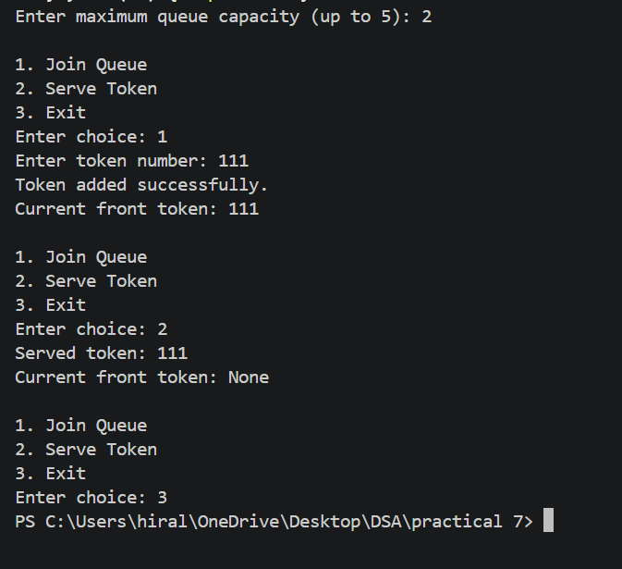
Problem 2: A hospital emergency ward receives patients continuously and attends to them strictly in the order they arrived, with no upper limit on how many can be waiting at once. New patients are added at the back and the doctor always attends to the patient at the front. Given a sequence of arrive and attend operations, implement this unlimited patient queue and print the current front patient after each operation. Describe how your solution differs from Problem 1 in how it manages capacity. What happens in your solution when the attend operation is called on an empty ward with no patients waiting?
CODE:
#include <iostream>
using namespace std;
struct Node
{
int patient;
Node* next;
};
int main()
{
Node *front = NULL, *rear = NULL;
int choice, patient;
while (true)
{
cout << "\n1. Patient Arrives";
cout << "\n2. Attend Patient";
cout << "\n3. Exit";
cout << "\nEnter choice: ";
cin >> choice;
if (choice == 1)
{
cout << "Enter patient ID: ";
cin >> patient;
Node* newNode = new Node;
newNode->patient = patient;
newNode->next = NULL;
if (front == NULL)
{
front = rear = newNode;
}
else
{
rear->next = newNode;
rear = newNode;
}
cout << "Patient added successfully.\n";
}
else if (choice == 2)
{
if (front == NULL)
{
cout << "Error: No patients waiting!\n";
}
else
{
Node* temp = front;
cout << "Attended patient: "
<< front->patient << endl;
front = front->next;
delete temp;
if (front == NULL)
rear = NULL;
}
}
else if (choice == 3)
{
break;
}
else
{
cout << "Invalid choice!\n";
}
if (front == NULL)
cout << "Current front patient: None\n";
else
cout << "Current front patient: "
<< front->patient << endl;
}
while (front != NULL)
{
Node* temp = front;
front = front->next;
delete temp;
}
return 0;
}
OUTPUT:
